BILL OF LADING OPTIONS FOR BROKERS - N-K-1 BOLFMT

Box Brokers do not want their friendly Vendor Box manufacturers name on shipments to their customers. They want their name on their bill of lading as well as the load tags if possible.  
Shipping from a Box plant to a Brokers customer is often called a blind shipment, meaning we hide the true box manufacturers name. Advantzware has several three options for Blind Shipments.

N-K-1 BOLFMT VIEW FORM allows a unique Bill of Lading Format for Each Broker.  
 Any shipment to any of their customers will use the form defined for them.  
This may include their company LOGO on their form. Custom designed forms or existing forms can be used. The XPRINT form has unique Logic to print the SOLD TO name and Address from Order Entry in place of a LOGO. The customer shipto file must have the BROKER toggle box checked.

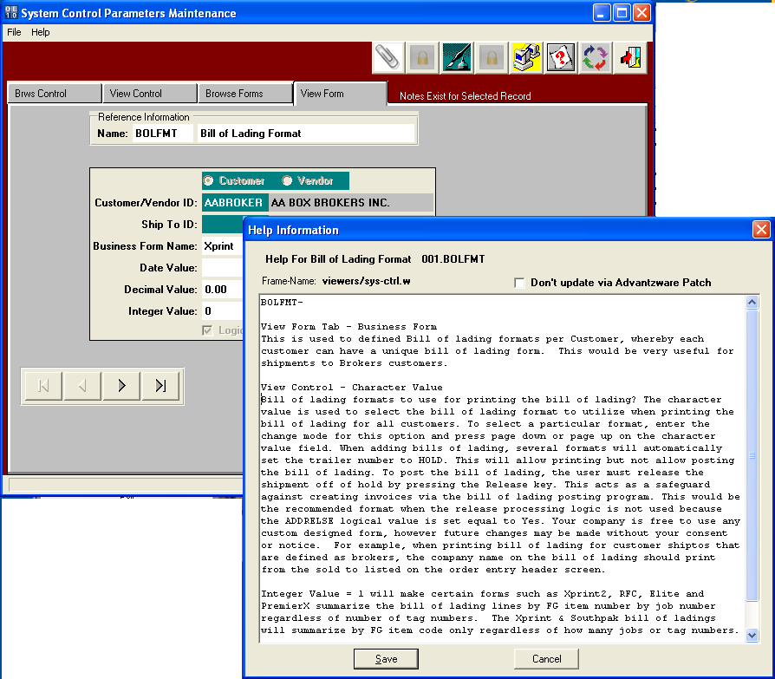

BILL OF LADING OPTIONS FOR BROKERS – N-K-1 BOLFMTX

Bill of Lading Print has an Option to Print a Broker / Freight Bill Form on Demand.  
You will need a library of Logos for each Broker if checking the Print Logo option.  
When Printing at BOL you can Opt to User the Broker BOL Form.   
The character value houses the forms that print when selecting this option.

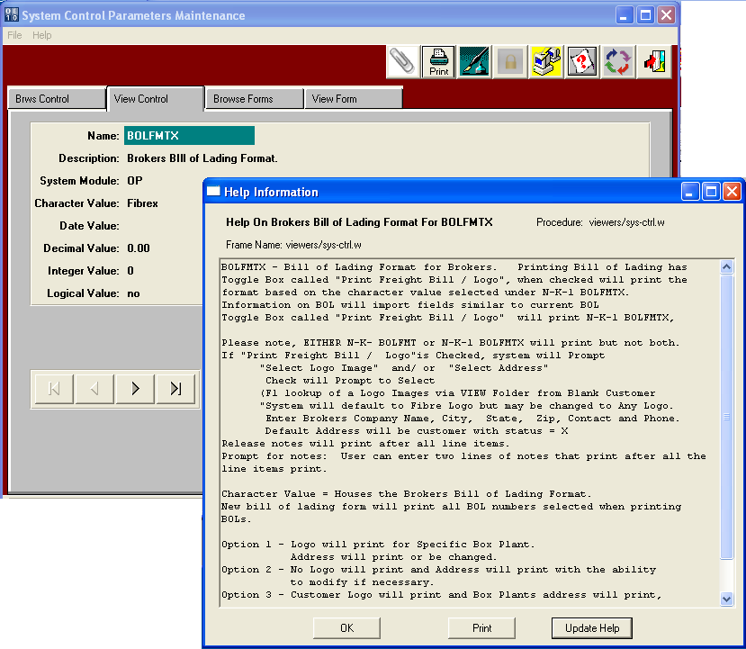

BILL OF LADING OPTIONS FOR BROKERS – N-K-1 BOLFMTX

Bill of Lading Print has an Option to Print a Broker / Freight Bill Form on Demand.  
To print the Freight Bill, you must check the toggle box called “Print Freight Bill / Logo?  
When printing this bill of lading format, you have an option to print a LOGO.  
The Logo may or may not include an address, city and state.   
Therefore, when selecting this option, you can opt to print the address.

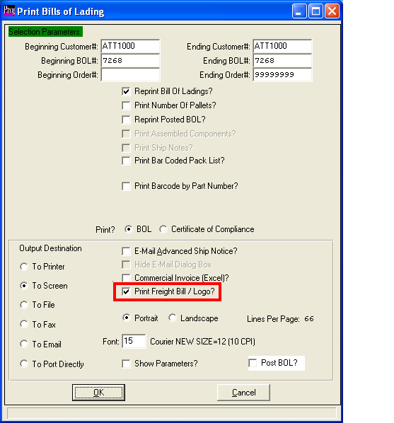

BILL OF LADING OPTIONS FOR BROKERS – N-K-1 BOLFMTX

This Freight Bill of Lading form allow you can pick a Logo and type the Address that Prints.  
Otherwise the Address will print from the Customer with Status X.

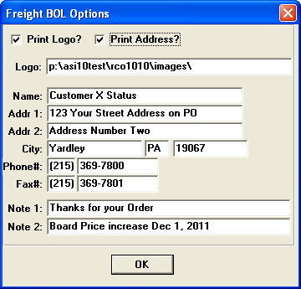

BILL OF LADING OPTIONS FOR BROKERS – N-K-1 BOLFMTX

This is an example of the Freight Bill of Lading without selecting a LOGO.

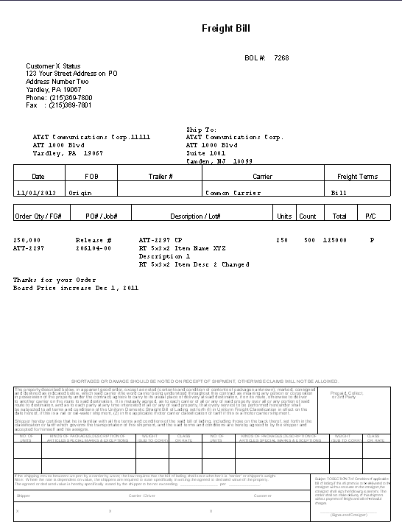

BILL OF LADING OPTIONS FOR BROKERS – Customer Shipto File

The Shipto File for each customer has an option to define the shipto as a Broker.  
When a bill of lading for this shipto location for this customer, the XPRINT bill of lading format will print the SOLD TO Address from the Orders View Tab in place of the normal Logo.

In other words, the Brokers name and address will print on the top of the Bill of Lading Form.

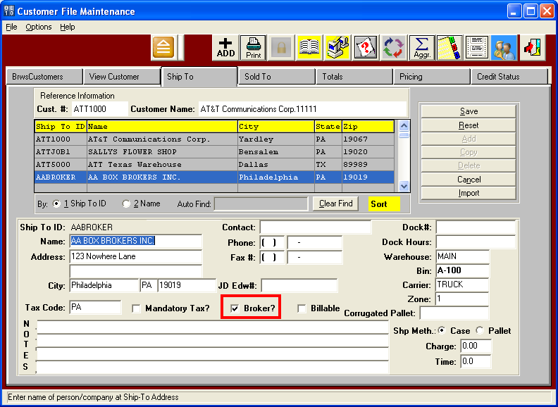

BILL OF LADING OPTIONS FOR BROKERS – Customer Shipto File

SOLD TO ADDRESS

The Sold To name and address will print on the XPRINT bill of Lading Format when the Shipto location in the customer shipto file is set to BROKER.

